**GUANTANAMO**

…he has sent me to bind up the broken hearted, to proclaim liberty to captives, and the opening of the prison to them that are bound…

Isaiah 61.1

When the first captives from the so-called War on Terror were sent to Guantanamo in January 2002, the Bush administration thought it had found a perfect legal “black hole.” Guantanamo was envisioned as a place beyond the reach of U.S. courts. No constitutional rights, no legal protections, and no lawyers would interfere with the government’s free rein to deal with the Guantanamo detainees however they wished. Indeed in the early days of Guantanamo, the U.S. would not even identify those men kneeling in orange jump suits with goggled eyes and bound hands and feet.

It is now more than 20 years later, and while some of the Guantanamo particulars have changed, the pall of those early days remains as a stain on the history and character of our country. Of the more than 750 men who were detained in Guantanamo over the years, only about 30 remain there today, but the scar on America’s principles is raw and painful. As long as Guantanamo remains open that scar will not heal, and its disfiguring effects will continue to serve as a lure for extremists and an impediment to moderates around the world who once respected and admired American reverence for such principles as respect for human dignity and the Rule of Law.

From 2005 until I retired nearly 10 years later, I represented three men imprisoned at Guantanamo. I was motivated to undertake this representation on a *pro bono* basis by a sense that our country’s core principles were threatened by the utter disregard for human rights and basic fairness that Guantanamo represented. Even if the men in Guantanamo were the “worst of the worst” – an often-used and now debunked expression of then Secretary of Defense Rumsfeld – they were entitled to be treated with human dignity and accorded at least some level of fairness. The use of torture, whatever euphemistic name we might give it, as a matter of national policy was very troubling to me. My background as a proud U.S. Marine and the son of a career Marine who was killed in Viet Nam in 1966 helped me understand that the Rule of Law was threatened by the abuses occurring at Guantanamo.

As a Jesuit-trained Catholic steeped in the Church’s traditions of social justice, I viewed as anathema the notion that my country could lock somebody up, throw away the key without making a reasonable effort to establish “guilt or innocence,” and then apply interrogation methods amounting to torture.

From the onset and throughout the course of my legal work on behalf of my Guantanamo clients, my faith community – the Pax Community – was a continuous source of spiritual support and comfort. When my clients were hunger striking to protest against deplorable conditions in Camp V, the Pax Community shared with me a felt sense of their anguish and pain. And when two of my clients were released and finally able to rejoin their families, the Pax Community celebrated with me the overwhelming sense of God’s loving mercy that was so concretely manifest.

I often describe my Guantanamo habeas work as the most rewarding, and at the same time the most frustrating, work of my 33 year legal career. Through the ups and downs of the representation Pax was a constant source of spiritual sustenance, communal support, and a perspective informed by Christ’s example of love – even love of one’s enemies.

The three men I represented came from very different backgrounds and cultures. One was a proud Saudi who was well educated and even spoke a little English due to his father’s employment with an Arab/American oil company. He was in a hospital in Afghanistan at the time he was “sold” to American forces. He overheard the negotiations outside his room for the amount of the “bounty” that the Americans would pay for him. Another of my clients was from Tajikistan. He and his family were refugees from the civil war in Tajikistan who were moved to a refugee camp near Kundoz in the northern part of Afghanistan. He was arrested in Mazar-e-Sharif in 2003 when he was misidentified as a terrorist fighter. In reality he was a van driver who was trying to work his way back home to his village in Tajikistan where his family had been resettled while he was in school in Pakistan. My third client was the last Russian in Guantanamo. Born on Russia’s easternmost Kamchatka peninsula, he and his family moved to Tatarstan in central Russia when he was a young boy. As a youth he studied ballet and later became a dancer with the Russian army. After he left the army and moved back to Tatarstan, he became more observant of his Muslim religious heritage. He married and had a son but was frustrated with official constraints and road blocks to his family’s ability to express their religious beliefs freely and without harassment. He left Russia in an effort to resettle with his family in a country more hospitable to Muslims. He was in Pakistan in 2002 when he was arrested by Pakistani authorities and turned over to U.S. forces.

My Saudi client was 23 years old when he was first imprisoned by the U.S. He was unjustly held for six years. He was never charged with any crime or violation of law. I will never forget the circumstances of his release from Guantanamo. I was at Guantanamo in July, 2007 for meetings with my clients. As I wrote in my journal on the flight to Guantanamo: “Another trip to Guantanamo. The excitement now dulled by routine. How many more trips will there be before substantive changes, real hearings and release?” On the first day of this trip I met with our Tajik client, who was warm and friendly as usual. Day two was a rare day off before visits with our Saudi and Russian clients, and I planned to use it to prepare for the client meetings ahead. As I organized my files and my thoughts in the lobby area of the lodging facility, the reception desk alerted me that there was a call for me from one of the lawyers assigned to the base. The lawyer told me that my Saudi client had been cleared for release and was expected to be sent home very soon. I remember my heart pounding and my hands shaking as I repeated this news to my colleagues. We scrambled to catch the ferry boat to the other side of the Bay where the detention facilities are located, so that we could meet with our client and have him sign some necessary papers related to his release. When we were able to get in to see him, although still chained in leg irons to the floor, he stood to greet us (even under these circumstances, he was always the gracious host) and with a big smile and a hug for me invited us to sit down. We confirmed for him the wonderful news that he would be released and would be going home to his family. He seemed overwhelmed and he threw his head back and looked heavenward. Then he looked at me and asked, “Is it true, I am going to be released?” When I said “yes.” He repeated the words, “I am going to be released.” We had some wonderful conversation about his home and family, and as our allotted time with him was running out, he presented me and my colleague with a picture he had drawn with colored pencils—an ornate frame of colorful flowers with words of thanks neatly written in the center. For days and weeks following this amazing experience the words of Bob Marley’s anthem “Exodus” coursed through my head: “Set the captives free…. Set the captives free….” The picture: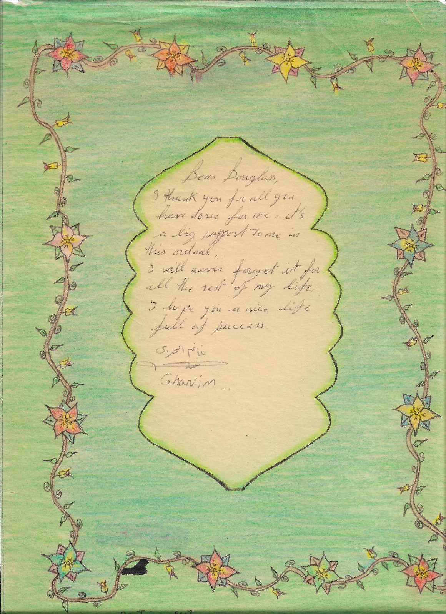

My client from Tajikistan was also 23 years old when he was arrested and sent to Guantanamo. He was quick-witted and plugged in to the rhythm of the detention facility. I recall a meeting with him in which he was describing in great detail his fellow prisoners and some of the routines of the facility. At the time, he and his fellow detainees were all in solitary confinement with no contact and very restrictive conditions. When I asked him how he knew so much about others and the facility, he looked at me, smiled and said, “You have your CNN, and we have our DNN.” I looked quizzical, and he explained, “Detainee News Network.” When I pressed further, he said the news came through the kitchens. This only heightened the mystery, since none of the detention facilities had kitchens and food was prepared in an off-site location and delivered to the detention facilities. This young man, who came from a very remote and impoverished village in Tajikistan, used some of his time in Guantanamo to teach himself several different languages, including English. He did so by obtaining from the library copies of the Koran in different languages and then laying them out side by side and deciphering the new words. When he was finally released and allowed to go back to his family’s small village, the stigma of Guantanamo followed him and he was not able to find a job. Irrepressible as always when I called him following his release, he invariably told me that things were “wonderful.” “I am fantastic, Mr. Douglas,” he would say, and then go on to explain that they had gotten electricity for three hours yesterday or that the Red Cross had dropped off a bag of onions. He married and had a little girl but was forced to go to Russia as a migrant worker in order to make money to send home. Russian authorities imprisoned him, beat him up and deported him back to Tajikistan. He was killed in an automobile accident while traveling back to his village. I spoke with his father, a respected cleric for the village. His father accepted his son’s death as the will of Allah, and he thanked me profusely for helping his son while he was in Guantanamo. Our team raised some money for the care of our client’s daughter and widow.

Our third client, a sometimes enigmatic Russian, was an armchair philosopher, an amateur historian and a professional dreamer. It took us many visits to convince him that we were really there to help him. He told us often that he was much less concerned about the case we had filed on his behalf than he was about the relationships and bonds we had established between us. The sweep and breadth of his journey from Russia to Tajikistan, to Afghanistan, and then to Pakistan was epic, and more than once we talked about the great movie it could be. I remember how, in our very first meeting with him in Guantanamo, he told us about ballet dancing with various troupes, including the Russian army. Then he looked at me and with a big smile asked, “In the history of the world has there ever been a ballet dancing terrorist?” I was always amazed at his ability to retain his sense of humor even under the dire conditions of Guantanamo. Over many years we also developed a close relationship with our client’s mother, whom we frequently called with updates about her son and requests for family news we could pass on to him. She was in her 70’s and a retired economist for the USSR. She told us that her prayer was to live long enough to see her son again. She was feisty and determined to do what she could to get her son released. She wrote letters to the Russian authorities, the United Nations and the President of the United States. She was a grandmother to our client’s son as well as the children of his brother, and she and I compared our joys of grandparenting. In one call she told us the story about the long train trip from Kamchatka to Tatarstan when our client was a small boy. She had brought on the trip several three liter jars of homemade jelly. One day while she and her older son were out picking potatoes, our client, being too young to help, stayed home. He got into the cupboard where the jelly was kept and dropped one of the big jars on the floor. He cleaned up all of the wasted jelly and broken glass before his mother returned home, but she saw that the jar was missing. She confronted our client, who admitted the infraction. She told us that she became very angry. Then she paused and said “I feel bad because I spanked him.” I could tell she was emotional, and she said, “I should not have spanked him.” After another pause I told her that it was clear to me that her son was a strong and disciplined man, whose strength of character and discipline had enabled him to bear up under the strains of Guantanamo for what was then seven years. I said that she shouldn’t be hard on herself, but should take some credit for raising such a strong son. In a quiet voice she responded, “Thank you.” Here is a photo of our Russian client’s mother in her kitchen holding a picture of him:

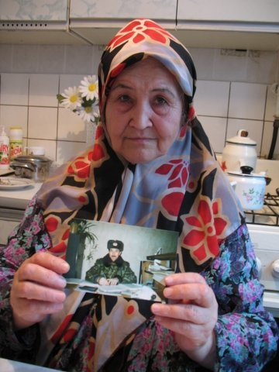

A final Guantanamo story has nothing to do with my clients. Or does it? At the end of one of my trips to Guantanamo I sat on the concrete deck of the lodging facility where the lawyers representing Habeas petitioners were housed. It was early morning, and I was alone waiting for the base bus to take me to the airstrip where I would catch the small charter flight back to Fort Lauderdale. As I waited, I thought about the week that had just passed. I had met with clients who desperately wanted to get out of Guantanamo and regain their freedom. I peered out across tall grass and scrub trees to the blue Caribbean and the Bay. The perimeter fence marking the boundaries of the base and the minefields beyond was punctuated by guard towers every few hundred yards. Lost in my reverie, it took me a few seconds to recognize the rustling of the bushes nearby as two scruffy looking men walked out into the roadway with their hands over their heads. As they got closer, I could see an older man and one perhaps in his late teens. Both were unshaven and both asked for “agua” as they approached with their hands held high. I motioned for them to sit and went to the front desk to tell the clerk and to get water. One of the charter flight crew, who spoke Spanish, came out and was able to determine that the two were an uncle and his nephew who had come from the far side of Cuba four days earlier, mostly at night and mostly by way of a small raft they had fabricated. They had avoided the Cuban police by coming along the coast at night. Somehow they avoided the minefields, the fences, concertina wire and guard towers and made it onto the base. They were fleeing communist Cuba, desperately seeking asylum and freedom in Guantanamo. As the base security personnel searched and questioned them, the morning call to attention sounded over the base loudspeakers. As the flag was raised and the “Star Spangled Banner” blared from loudspeakers all over the base, everyone and all traffic stopped and saluted the flag. One of the security guards motioned for the two men to stand and face the flag which they did in a sign of respect for their new country. It struck me how I had just spent a week with men who desperately wanted to get out of Guantanamo only to be witness to men who would risk their lives to get into Guantanamo and receive asylum in the U.S. The pull of freedom is strong, and governments should be wary of taking it away. Principles such as those enshrined in the “Great Writ” of Habeas Corpus should be available in a timely and meaningful way to those who are detained, especially those detained by executive fiat. Here’s an early picture of the perimeter fence and an old guard tower at Guantanamo:

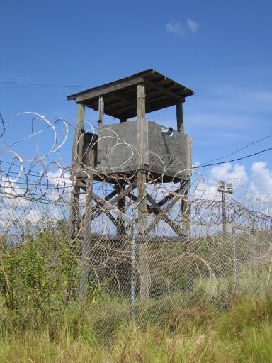

In April 2010 I tried the Habeas Corpus case of my Russian Guantanamo client. For five days the Federal Judge hearing the case listened to the evidence and arguments presented by both sides. At the end of the trial the Judge did not rule immediately but rather took the matter under advisement. Although I desperately wanted the Judge to order the release of my client, in many ways my personal objectives had already been achieved. A trial by an impartial fact finder with at least minimum standards of fairness and an application of the Rule of Law were my fundamental goals – goals that had been met. On May 13, 2010 the Judge issued a Memorandum Opinion and Order, granting our client’s petition for a Writ of Habeas Corpus and directing his release. Although the government appealed the Judge’s ruling, it was never overturned. Our client was released to the United Arab Emirates in 2017, where he unfortunately remains in detention.